|  |  |  |  |
| --- | --- | --- | --- |
| **VM Subnet** | **IP Subnet** | **Network Range** | **Broadcast** |
| R1(eth1), R2(eth0), Kali(eth0) | 10.10.10.0/29 | 10.10.10.1/29 – 10.10.10.6/29 | 10.10.10.7/29 |

1. **Copies of the conf files under /etc/frr/frr.conf for each of R1 and R2.**

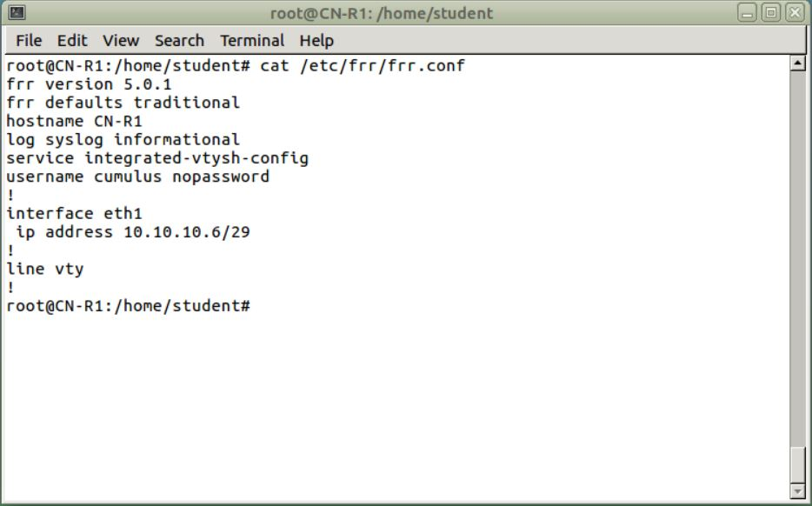

Capture 1 Config Files for R1

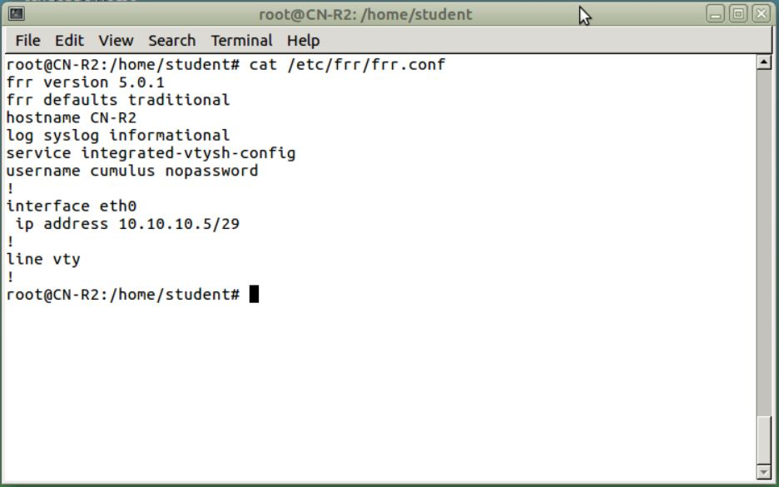

Capture 2 Config File for R2

1. **The Ethernet addresses of R1, R2 and Kali**

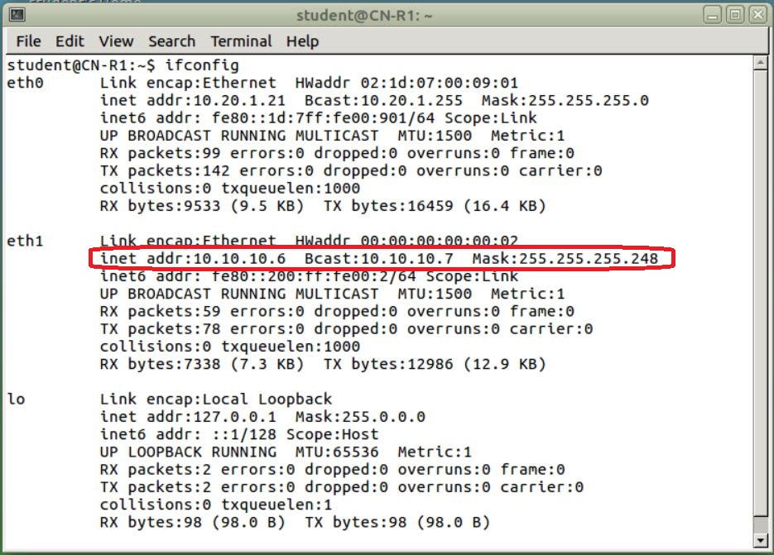

Capture 3 Ethernet Address R1

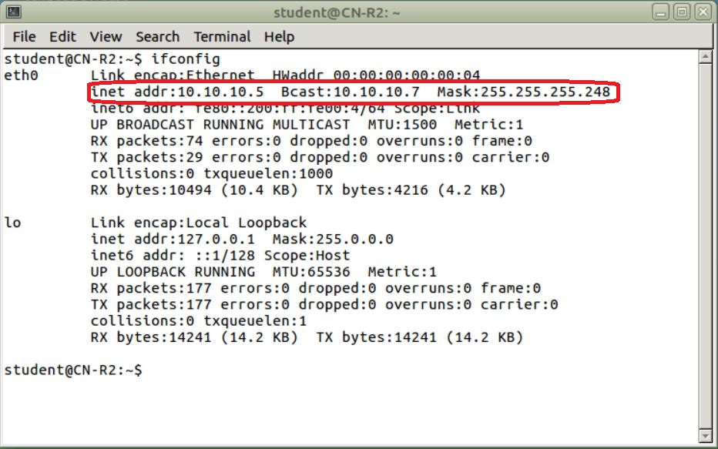

Capture 4 Ethernet Address R2

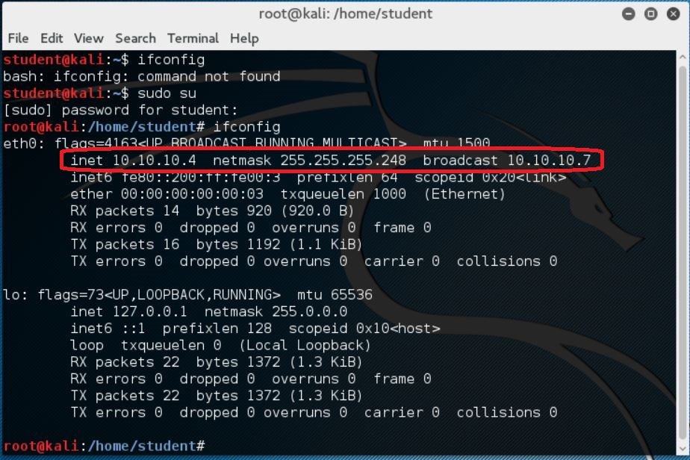

Capture 5 Ethernet Address Kali

1. **A copy of the /etc/network/interfaces file for Kali.**

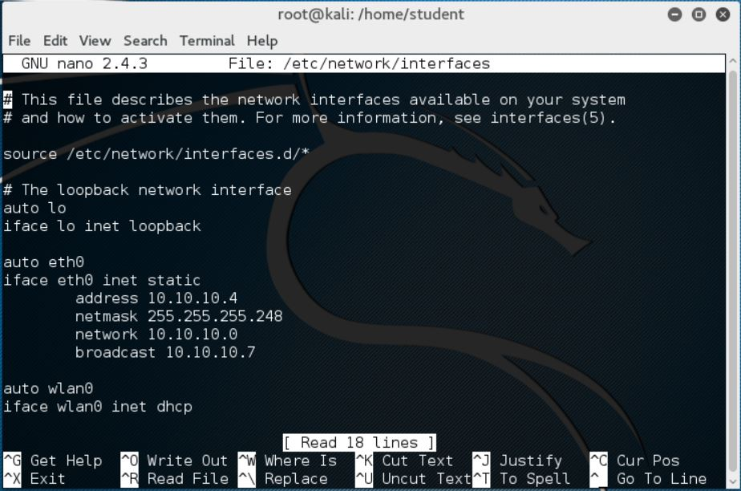

Capture 6 /etc/network/interfaces file

1. **Pinging between R1, R2 and Kali. From Kali ping R1 and R2.**

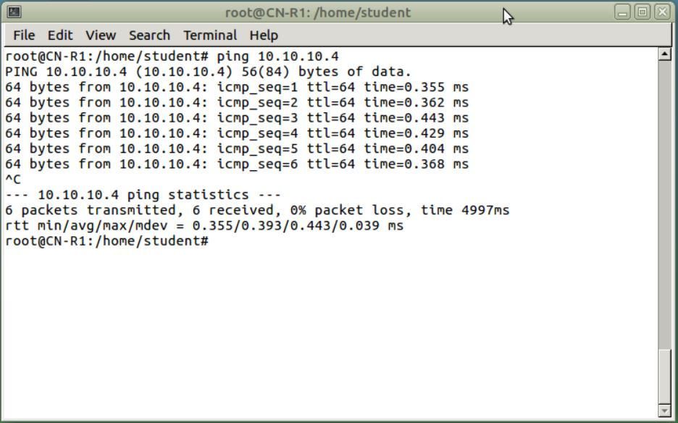

Capture 7 Ping R1 to Kali

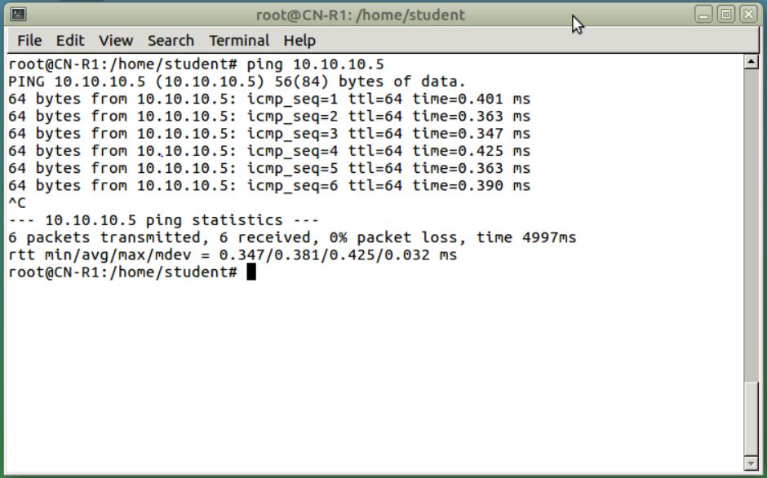

Capture 8 Ping R1 to R2

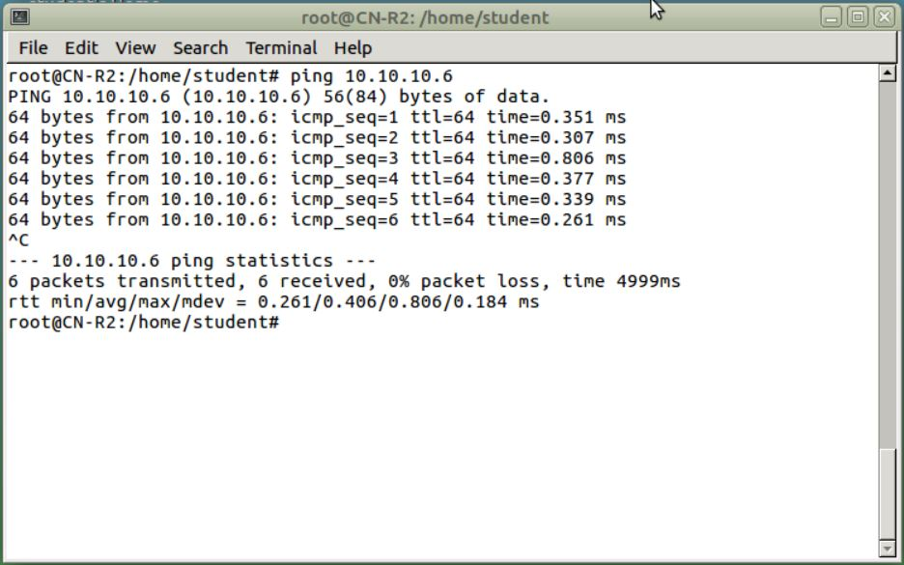

Capture 9 Ping R2 to R1

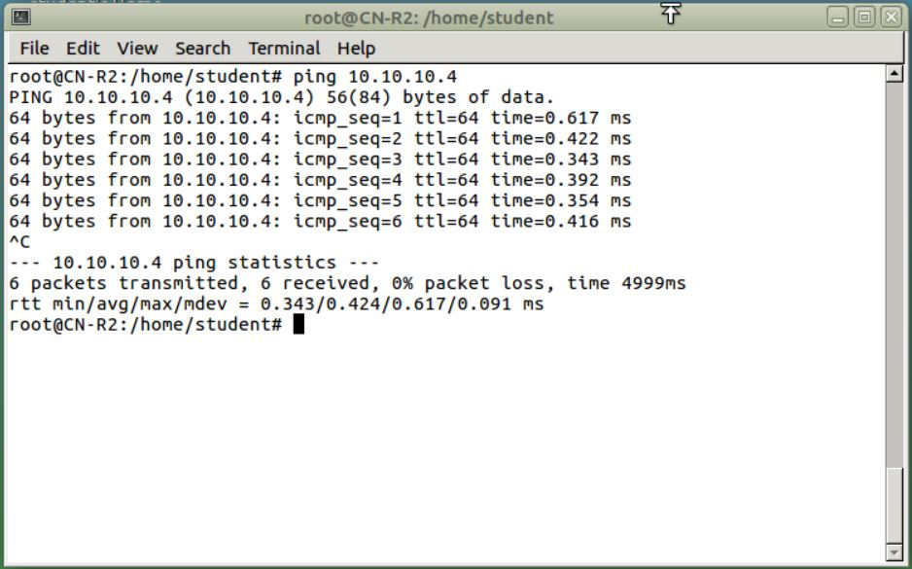

Capture 10 Ping R2 to Kali

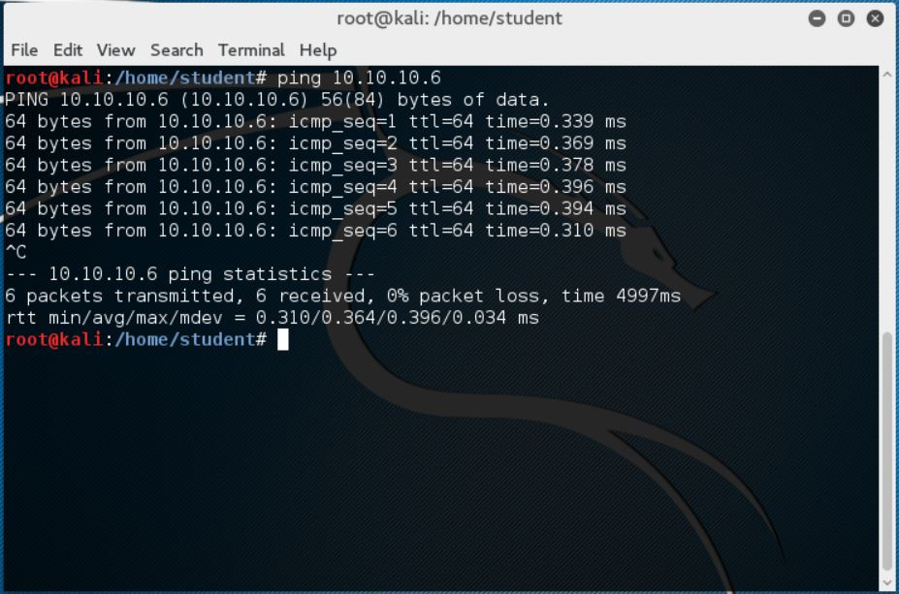

Capture 11 Ping Kali to R1

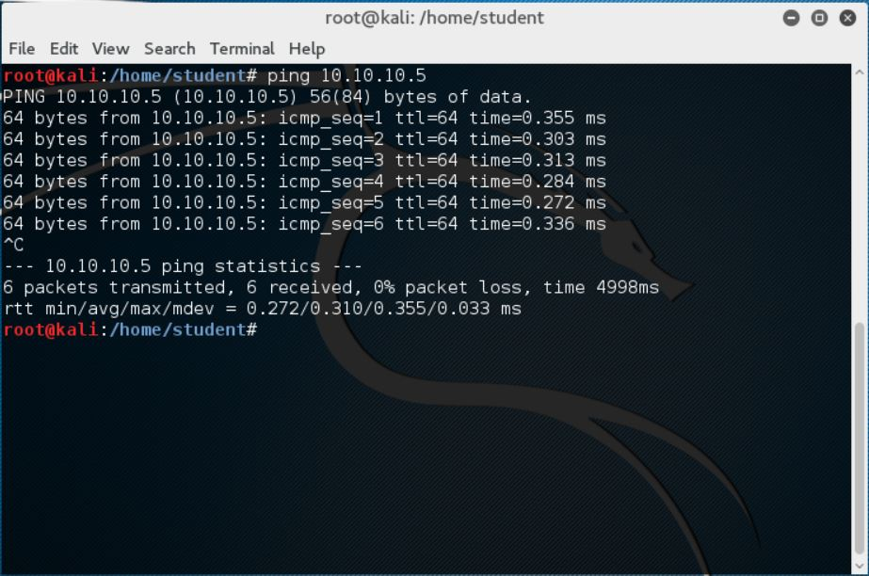

Capture 12 Ping Kali to R2

1. **Copies of the ARP tables on R1, R2 and Kali.**

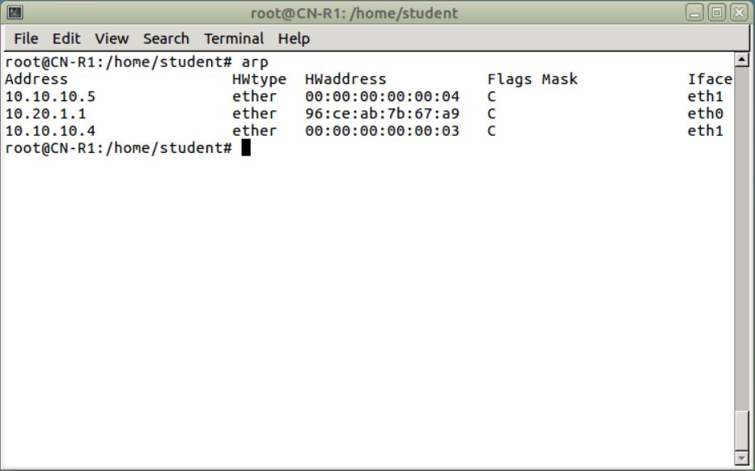

Capture 13 ARP Tables R1

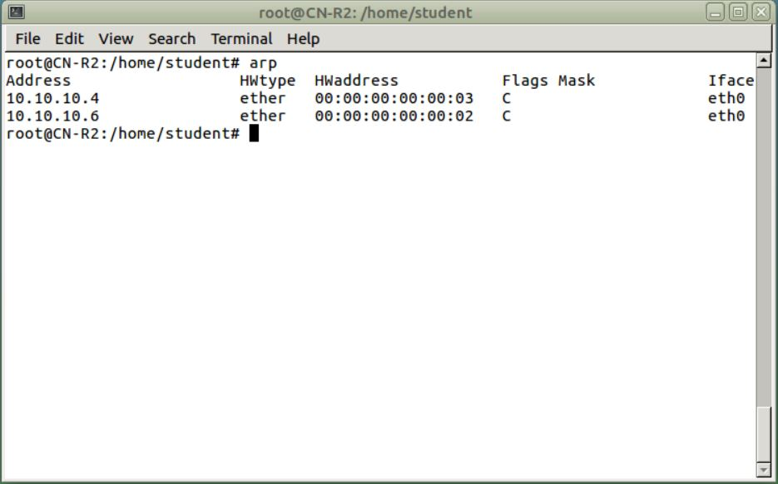

Capture 14 ARP for R2

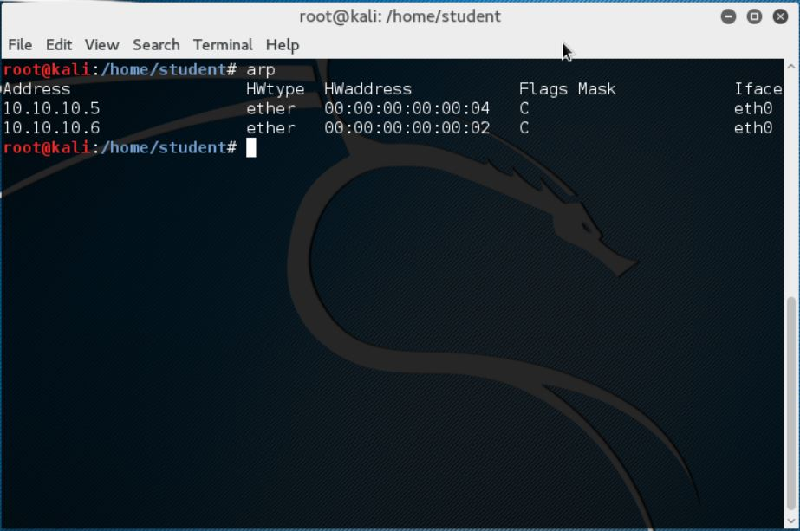

Capture 15 ARP for Kali